Lab Evaluation:

Course Name: Object Oriented Programming |  |  |  | Course Code: CMPE 221L
Assignment Type: Lab |  |  |  | Dated: 1-07-2026
Semester: 2rd |  |  |  | Session: 2025
Lab/Project/Assignment #: 4 |  |  |  | CLOs to be covered: CLO1
Lab Title: Classes & Objects |  |  |  | Teacher Name: Hafiz Muhammad Mubashar
CLO1 | Implement abstraction and encapsulation to develop reusable classes for objects of real-world problems
Levels (Marks) | Level1 | Level2 | Level3 |  | Level4 | Level5 | Level6
(10)
Total |  |  |  |  |  |  | /10

Rubrics for Current Lab Evaluation
Scale | Marks | Level | Rubric
Excellent | 9-10 | L1 | Submitted all lab tasks, BONUS task, have good understanding.
Very Good | 7-8 | L2 | Submitted the lab tasks but have good understanding
Good | 5-6 | L3 | Submitted the lab tasks but have weak understanding.
Basic | 3-4 | L4 | Submitted the lab tasks but have no understanding.
Barely Acceptable | 1-2 | L5 | Submitted only one lab task.
Not Acceptable | 0 | L6 | Did not attempt

LAB No. 4
Lab Goals/Objectives:
- Basic OO programming in java
- Objects and Classes

University Of Engineering and Technology, Lahore Computer Engineering Department
Equipment Required: Inteli J IDEA Edition Community, Net Beans with JDK 13 Version, Visual Studio.
Theory/Relevant Material: Objects and classes, constructors, getter & setters, modifiers
- Thinking of Time as an entity JTime class was created. Each object of this class represents a time-stamp (a mark in history). It has three attributes (hour, minute, second) and three constructors along with some other functions. Enhance its functionality by added following functions to it and test the functionality by updating the driver function.
  - Add a function that finds the time elapsed in seconds between two time-stamps.
  - Add a function that finds the time elapsed in two time-stamps in format of another time-stamp.
  - Add another constructor that takes total number of seconds elapsed after 12 am and construct the timestamp accordingly.
- We are going to develop a menu-driven application to manage a simple bank account class. It supports the following operations
  - Deposit money (to add an amount in current balance)
  - Withdraw money (to subtract an amount from the current balance)
  - Check balance (to display current balance of customer)
Note: Use a Switch statement to enter the choice of operation from the user. For initially create a function withname saving account to store the current balance of the customer. Write a Java class along with a driver program to test it.
Something is Brewing:

- So lately Ali has been walking as per your instructions. Avoiding obstacles in its path. Now Hasan wants to startwalking with Ali. But Hasan will walk randomly and will avoid the same obstacles as Ali. Write a code that will simulate both the walk patterns of Ali and Hasan simultaneously. Output can e of the form:
Starting: Ali's Location is = (0 : 0) Hassan's Location is = (0 : 0) Hasan has Random Movement, Ali follows order ALi: Where should i go now: v Ali is at = (0 : -1)
Hasan is at = (0 : 1)
ALi: Where should i go now: ^ Ali is at = (0 : 0) Hasan is at = (0 : 2)

ALi: Where should i go now: ^ Ali is at = (0 : 1) Hasan encounters hurdle at (1:2) Hasan is at = (0 : 2)

TASK 1:
class jtime {
int hour;
int minute;
int second;

public jtime(int hour, int minute, int second) {
this.hour = hour;
this.minute = minute;
this.second = second;
}
public int dif(jtime other){
int total_seconds1 = this.hour * 3600 + this.minute * 60 + this.second;
int total_seconds2 = other.hour * 3600 + other.minute * 60 + other.second;
return total_seconds2 - total_seconds1;

}

public jtime difference(jtime other) {
int total_seconds1 = this.hour * 3600 + this.minute * 60 + this.second;
int total_seconds2 = other.hour * 3600 + other.minute * 60 + other.second;
int diff = total_seconds2 - total_seconds1;
int timeelapse_hour = diff / 3600;
int timelapse_minutes = (diff % 3600) / 60;
int timelapse_seconds = diff % 60;
return new jtime(timeelapse_hour, timelapse_minutes, timelapse_seconds);
}
public jtime(int total_seconds){
this.hour= total_seconds/3600;
int remaining_seconds= total_seconds % 3600;
this.minute = remaining_seconds / 60;
this.second = remaining_seconds % 60;
}

}

public class time {
public static void main(String[] args) {
jtime t1 = new jtime(10, 20, 30);
jtime t2 = new jtime(12, 25, 38);
jtime t3= new jtime(3783);
System.out.println(t3.hour + ":" + t3.minute + ":" + t3.second + ":");
int d= t1.dif(t2);
System.out.println(d);
jtime elapsed = t1.difference(t2);
System.out.println(elapsed.hour + ":" + elapsed.minute + ":" + elapsed.second);
}
}

RESULT:
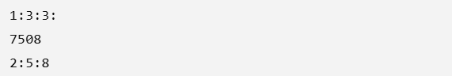

TASK 2:
import java.util.Scanner;
class savingaccount{
double currentbalance=0;
public void deposit(double amount){
currentbalance += amount;
}
public void withdraw(double amount){
if (amount <= currentbalance){
currentbalance -= amount;
}else{
System.out.println("you have insufficient balance");
}
}
public void showbalance(){
System.out.println("your current balance is" + currentbalance);
}
}
public class bank{
public static void main(String[] args){
savingaccount s1= new savingaccount();
Scanner sc= new Scanner(System.in);
int choice = 0;
while (choice != 4){
System.out.println(1 +" " + "deposit money");
System.out.println(2 + " " + "withdraw money");
System.out.println(3 + " " + "show balance");
System.out.println(4 + " " + "exit");
choice= sc.nextInt();
switch (choice){
case 1:
System.out.println("how much amount to deposit");
double depositamount= sc.nextDouble();
s1.deposit(depositamount);
break;
case 2:
System.out.println("how much amount to withdraw");
double withdrawamount= sc.nextDouble();
s1.withdraw(withdrawamount);
break;
case 3:
s1.showbalance();
case 4:
System.out.println("you have exit");
break;

}

}
}
}

RESULT:
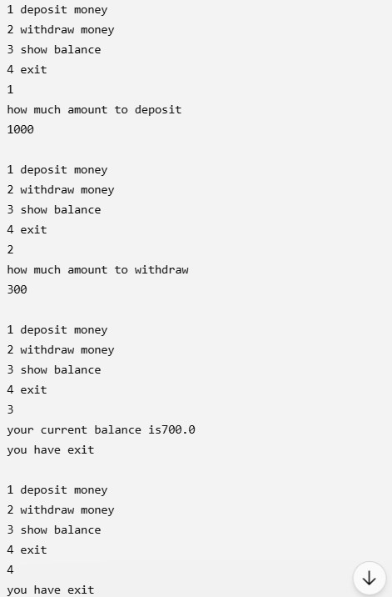

TASK 3:
import java.util.Random;
import java.util.Scanner;
class walker{
int x;
int y;

public walker(int x, int y) {
this.x = x;
this.y=y;
}
public void moveup(){
y = y + 1;
}
public void movedown(){
y = y - 1;
}
public void moveright(){
x = x + 1;
}
public void moveleft(){
x = x - 1;
}
public void display(String name ){
System.out.println(name + " is at = (" + x + " : " + y + ")");
}
}

public class walk {
public static void main(String[] args){
walker ali= new walker(0,0);
walker hasan = new walker(0,0);
Scanner sc = new Scanner(System.in);
Random r = new Random();
ali.display("ali");
hasan.display("hasan");
int [] hurdlex = {1,2,-1};
int [] hurdley= {2,3,-1};
while(true){
System.out.println("ali where do you want to move ( ^ v > < ) ");
char move = sc.next().charAt(0);
if (move== '^'){
ali.moveup();
} else if (move == 'v') {
ali.movedown();
} else if (move == '>') {
ali.moveright();
} else if (move == '<') {
ali.moveleft();
}else{
System.out.println("Invalid direction");
}
int direction = r.nextInt(4);
int newx = hasan.x;
int newy = hasan.y;
if(direction == 0 ){
newy += 1;
} else if (direction== 1) {
newy -=1;
}else if (direction==2){
newx +=1;
}else if (direction == 3){
newx -=1;
}else {
System.out.println("Invalid direction");
}
boolean hurdle = false;
for (int i = 0; i < hurdlex.length; i++){
if (newx== hurdlex[i] && newy==hurdley[i]){
hurdle = true;
System.out.println("hasan encountered a hurdle at (" + newx + "," + newy+")");
break;
}
}
if (!hurdle){
hasan.x=newx;
hasan.y=newy;

}
ali.display("ali");
hasan.display("hasan");
System.out.println();

}

}
}

RESULT:
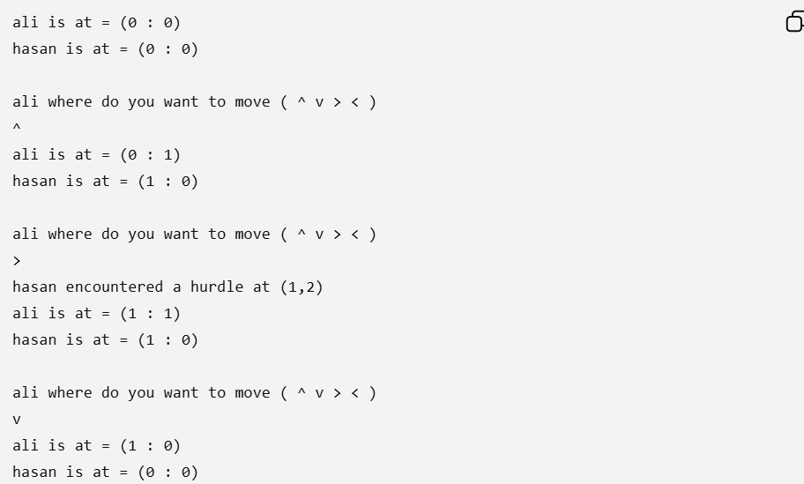

CONCLUSION:
The last three programs demonstrate the use of Object-Oriented Programming (OOP) concepts along with practical problem-solving in Java. The first program performs time calculations by finding the difference between two times and converting seconds into hours, minutes, and seconds using constructors and methods. The second program simulates a simple bank account system, allowing users to deposit, withdraw, and check their balance through a menu-driven interface while using methods to manage account operations. The third program creates a 2D walking simulation in which one character moves according to user input and another moves randomly while avoiding hurdles, demonstrating the use of classes, objects, loops, arrays, conditional statements, user input, and random number generation. Overall, these programs strengthen the understanding of OOP, constructors, methods, control structures, and real-world application development in Java.

